**25. I want to run a parallel query in rac database, But I need to make sure that, the parallel slave processes will run only on node where i am running the query and it will not move to other node.**

We can set **Parallel_force_local** parameter to TRUE at session level and then run the parallel query. All the px processes will run only on that node.

**59. Explain the backup frequency of OCR.**

OCR backup is created at every four hours automatically.

**ocrconfig -showbackup** - > command to check manual ocr backup.

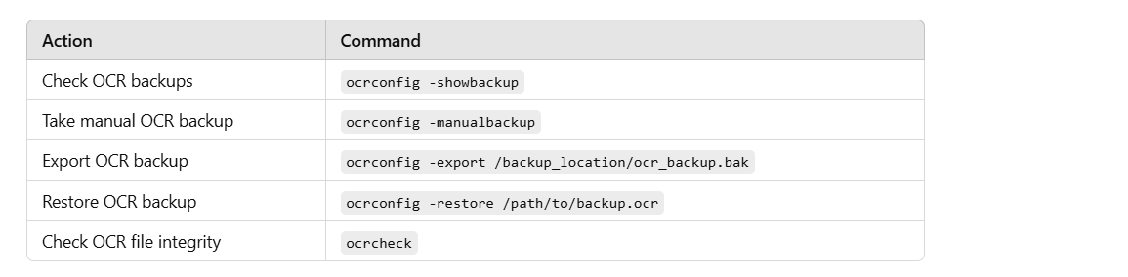

**63. If olr file is missing ,How can you restore olr file from backup**

# crsctl stop crs -f  
# touch $GRID_HOME/cdata/<node>.olr  
# chown root:oinstall $GRID_HOME/cdata/<node>.olr  
# ocrconfig -local -restore $GRID_HOME/cdata/<node>/backup_<date>_<num>.olr  
# crsctl start crs

Link: <https://dbakeeda.blogspot.com/2016/04/oracle-local-registry-olr-in-rac.html>

Link: <https://dbaclass.com/article/oracle-local-registryolr-rac/>

**64. Someone deleted the olr file by mistake and currently no backups are available. What will be the impact and how can you fix it?**

If OLR is missing, then if the cluster is already running, then cluster will run fine. But if you try to restart it , It will fail.

So you need to do below activities.

**On the failed node:**

# $GRID_HOME/crs/install/rootcrs.sh -deconfig -force  
# $GRID_HOME/root.sh

**80. OCR file has been corrupted, there is no valid backup of OCR. What will be the action plan?**

In this case , we need to deconfig and reconfig.

deconfig can be done using rootcrs.sh -deconfig option

and reconfig can be done using gridsetup.sh script.

**27. What are the storage structures of a clusterware?**

2 shares storage structure – OCR , VD

2 local storage structure – OLR, GPNP profile.

**31. What is the purpose of Voting disk?**

Voting disk stores information about the nodes in the cluster and their heartbeat information. Also stores information about cluster membership.

**32. Why we need voting disk?**Oracle Clusterware uses the VD to determine which nodes are members of a cluster. Oracle Cluster Synchronization Service daemon (OCSSD) on each cluster node updates the VD with the current status of the node every second. The VD is used to determine which RAC nodes are still in the cluster should the interconnect heartbeat between the RAC nodes fail.

**28. What is OLR and why it is required?**

While starting clusterware, it need to access the OCR , to know which resources it need to start. However the OCR file is stored inside ASM, which is not accessible at this point( because ASM resource also present in OCR file.)

To avoid this, The resources which need to be started on node is stored in  operating file system called as OLR ( Oracle local registry). Each node will have their OLR file.

So when we start the clusterware, this file will be accessed first.

**29. What is OCR and what it contains?**

OCR is the central repository for CRS, which stores the metadata, configuration and state information for all cluster resources defined in clusterware.

node membership information

status of cluster resources like database,instance,listener,services

ASM DISKGROUP INFORMATION

Information ocr,vd and its location and backups.

vip and scan vip details.

**30. Who updates OCR and how/when it gets updated?**

OCR is updated by clients application and utilities through CRSd process.

1.tools like DBCA,DBUA,NETCA,ASMCA,CRSCTL,SRVCTL through CRsd process.

2. CSSd during cluster setup

3.CSS during node addition/deletion.

Each node maintains a copy of OCR in the memory. Only one CRSd(master) , performs read, write to the OCR file . Whenever some configuration is changed, CRSd process will refresh the local OCR cache and remote OCR cache and updates the OCR FILE in disk.

So whenever we try get cluster information using srvctl or crsctl , then it uses the local ocr for fetching the data . But when it modify , then through CRSd process, it will updates the ocr physical file).